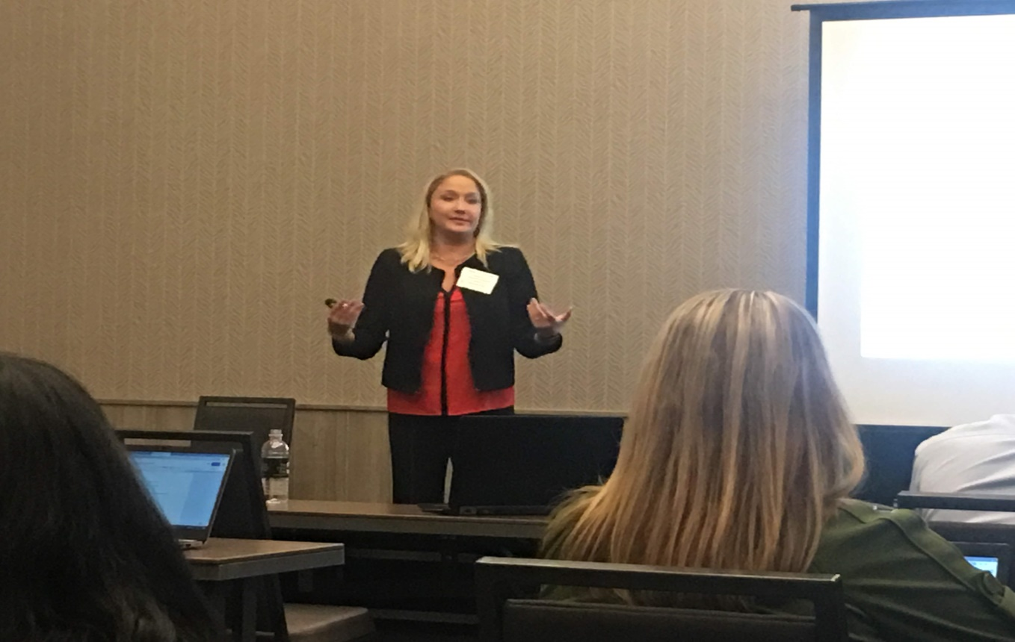 MCESC Dir. of SEL Jessica Davies presenting at SEL symposium in Denver, COL.

Jessica Davies is the Director of Social Emotional Learning Services for the Montgomery County Educational Service Center in Dayton, Ohio. The SEL Division of the MCESC supports school districts with implementing whole-child focused initiatives including creating trauma informed SEL schools, integrating systematic social emotional learning practices, comprehensive prevention programming, staff wellness initiatives, and consultation regarding students with intensive needs. Jessica is a licensed school administrator and school psychologist who has worked in various school districts in Pennsylvania, Massachusetts, and Ohio, serving both urban and suburban populations. She is passionate about sharing evidence-based strategies, based on the latest neuroscience, in order to help educators and students have the best chance of reaching their full potential. Jessica holds a B.A. in Communications from American University, a M.S. in Educational Psychology and a Certification of Advanced Graduate Study in School Psychology from Northeastern University.

